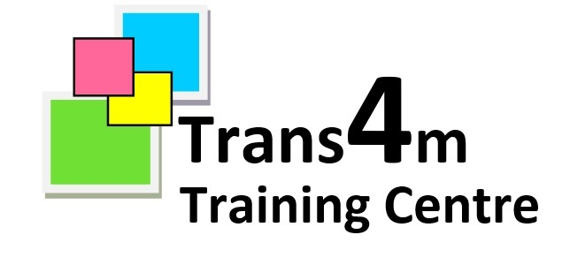

Behaviour Policy

TRANS4M is a community interest company committed to providing young people training and learning opportunities in a supportive and safe environment to aid their entry into the world of work.

This behaviour policy is intended to support that overriding purpose. Many of the young people attending Trans4m come from a disadvantaged background and may find managing their own emotions and behaviour more difficult than will their peers in mainstream education and training. This policy tries to anticipate the likely problems that may occur in teaching and ensure that the staff understand the most effective means of avoiding or resolving these problems.

Aims:

- To provide a framework which supports learning
- To provide a positive, safe, caring learning environment where every person is valued and respected as an individual
- To promote self-esteem and awareness
- To encourage the exploration of values and moral issues and to develop these values through practical use in everyday life
- To develop in students a sense of self-discipline and an acceptance of responsibility for their own actions
- To help young people to overcome their emotional and behavioural difficulties
- Ensure each person’s needs are recognised and each has an equal opportunity, irrespective of colour, ethnic origin, religion, gender, sexual orientation or disability, to realise their highest potential

Definitions of good behaviour and expected code of conduct at Trans4m:

- Ensure you respond and follow any reasonable instruction from all staff
- Always treat other students, staff and visitors to the centre and the local public in a respectful manner including respect and tolerance of different cultures and faiths
- Understanding and respecting the fact that other people have rights, feelings and opinions
- Helping to make the centre a safe, pleasant and easy place to learn in
- Looking after your own and other people’s property, including property and premises of Trans4m
- Being truthful and willing to discuss problems and accept consequences
- Listening to people and speaking politely
- Helping to keep the centre clean, tidy and undamaged, no spitting in or around Trans4m premises
- Looking after your own and other people’s property
- Not damaging or misusing any of Trans4m’s property or buildings deliberately or by gross negligence

- Not behaving in any way that could bring Trans4m into disrepute
- Not disrupting teaching or working areas

To support workshop and classroom management the tutors will ensure that the following rules apply, but there is always discretion used in the application of the rules, positive engagement is above all the priority.

- No hats, personal stereos or other unnecessary items to be worn, unless with the specific permission of the tutor
- No drinking or eating in the training areas unless with the tutors permission
- Bags to be stored away neatly, not to be carried around on students body
- Appropriate clothing and equipment to be used in each session, as per the areas requirements, this includes steel toe capped boots in the construction area
- No using of mobile phones during sessions, phones are to be stored away and either switched off or on silent during sessions
- Sessions to start on time and discretion to be used with respect to going to the toilet and comfort breaks in lesson time
Trans4m cannot accept responsibility for any items such as phones brought into the centre.

Smoking and Vaping: is not permitted in any of the Trans4m buildings, nor in front of any of the entrances, recharging vapes is also not permitted in the centre. Trans4m will aim to raise awareness of the dangers of smoking and vaping.

Drugs and Alcohol: Trans4m has a zero tolerance policy on drugs and alcohol. This includes non prescribed substances that may impair concentration, judgement or behaviour. If you are taking prescription medication, please let your supervisor know. If you are found with any alcohol or drugs it may be considered as gross misconduct for which you may be permanently excluded. Energy drinks are not to be drank on site during the day or at lunchtime, any student who appears to be under the influence of an energy drink will be sent home.

The use of “reasonable force” within the centre: There are circumstances when it is appropriate for a staff member to use “reasonable force” to safeguard children The term “reasonable force” covers a broad range of actions used by staff that involve a degree of physical contact to control or restrain children. This can range from guiding a child to safety by the arm, to more extreme circumstances such as breaking up a fight or where a child needs to be restrained to prevent violence or injury. “Reasonable” in these circumstances means “using no more force than is needed”. The use of force may involve either passive physical contact, such as standing between pupils or blocking a pupil’s path, or physical contact such as leading a pupil by the arm out of the classroom.

Prohibited Items:

Students are prohibited from bringing onto the premises items that include:
- Knives or weapons
- Illegal drugs
- Stolen items
- Any article that the member of staff reasonably suspects has been, or is likely to be, used to commit an offence, or to cause personal injury to, or damage to the property of, any person (including the student)
- Alcohol
- Fireworks
- Pornography

Trans4m have in place a “Searching, Screening & Confiscation” policy that sets out the procedures that will be used and followed when necessary, this includes Trans4m’s right to carry out a search if there is any suspicion and also includes the right to periodically carry out searches throughout the year.

Disciplinary process

In lessons, Trans4m follow the ‘choices, chances, consequences’ system:

- Choices – Make positive choices about the way you behave
- Chances – Take the chances we give you as learning opportunities
- Consequences – Don’t allow consequences to impact your learning and future goals

Warnings will be used if you have not responded to warning or interventions with your tutor, or in cases of gross misconduct (see list C).

C: Some examples of gross misconduct
- Physically assaulting staff, other students, or visitors
- Deliberately damaging Trans4m property
- Theft of staff, student or Trans4m property

1. Formal Warning and behaviour agreement
The student will be suspended until a meeting can be completed with the tutor, a manager and a parent / carer / support worker (where available). During this meeting, the most recent incident will be discussed along with all past interventions. Student will sign a behaviour agreement based on the incident(s).

2. Written warning and review of programme
The student will again be suspended, and the case will be discussed with the Centre Manager before a decision can be made on whether the student may continue attending all or part of their programme. A meeting would then take place with student and their representative to discuss the outcome.

3. Final written warning at discretion of manager
Following these stages, a full exclusion may be authorised by the Management team unless there is clear evidence that the learner can complete some part of their programme.

